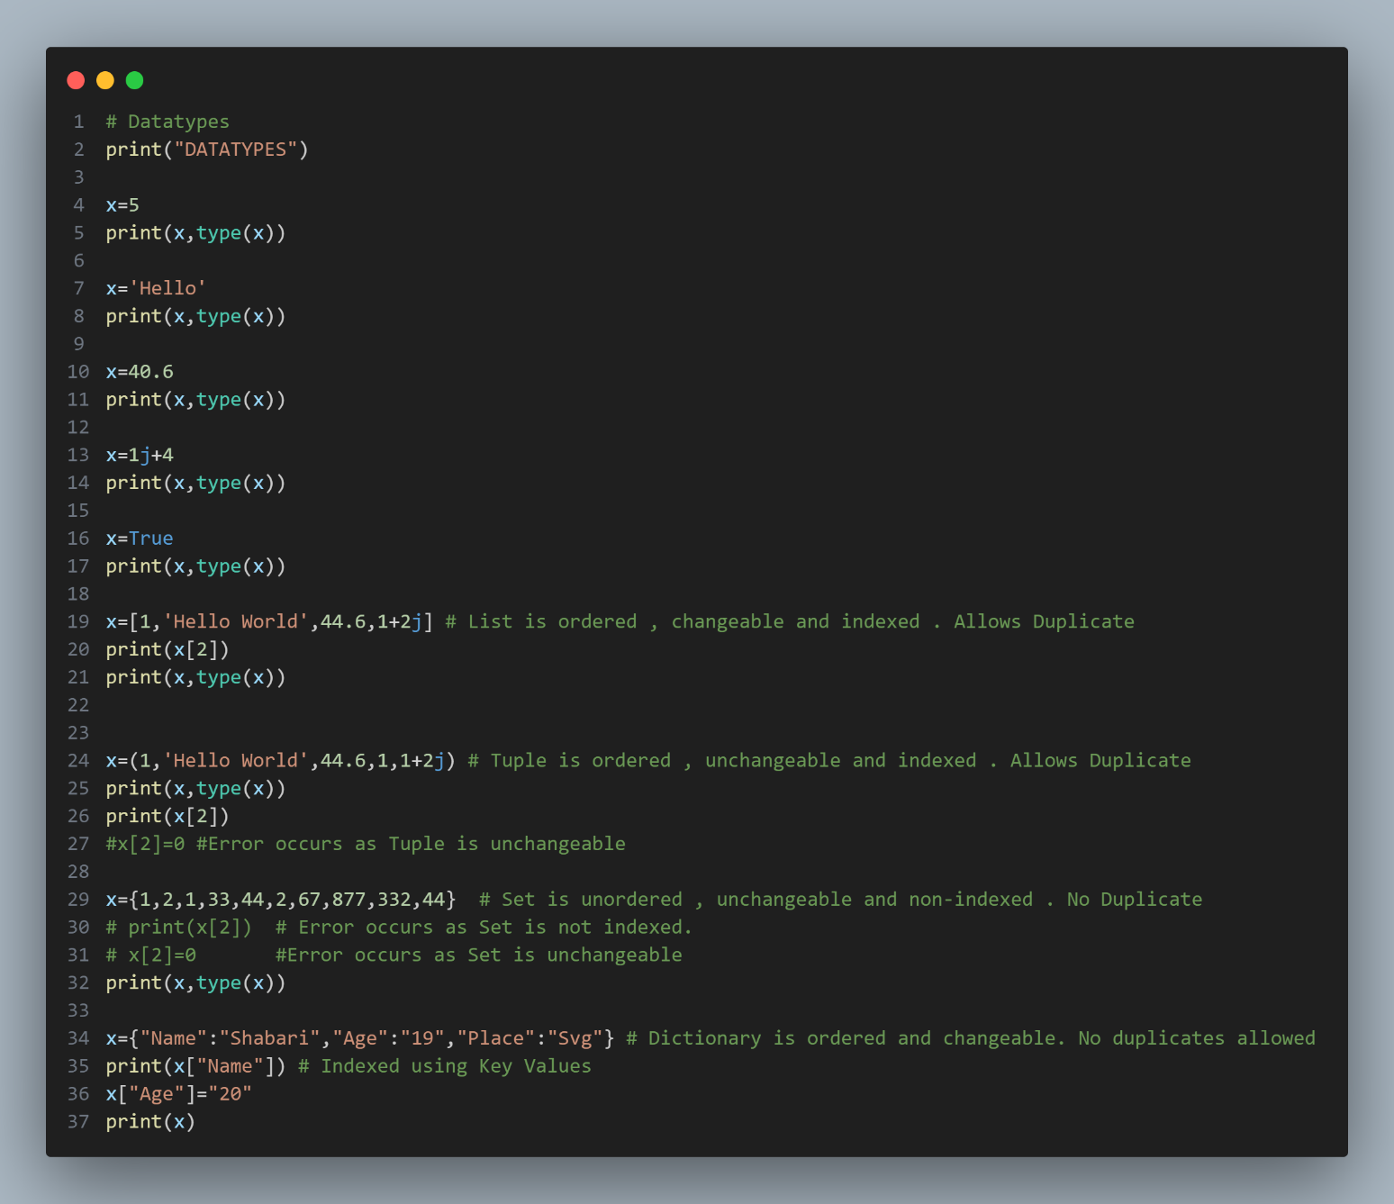**IMPLEMENTATION OF BASIC DATATYPES**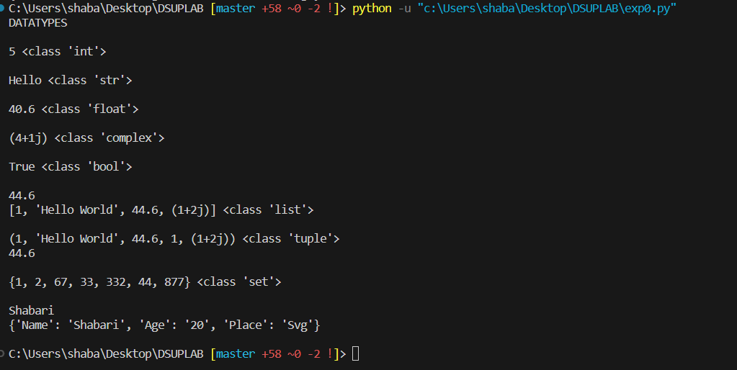

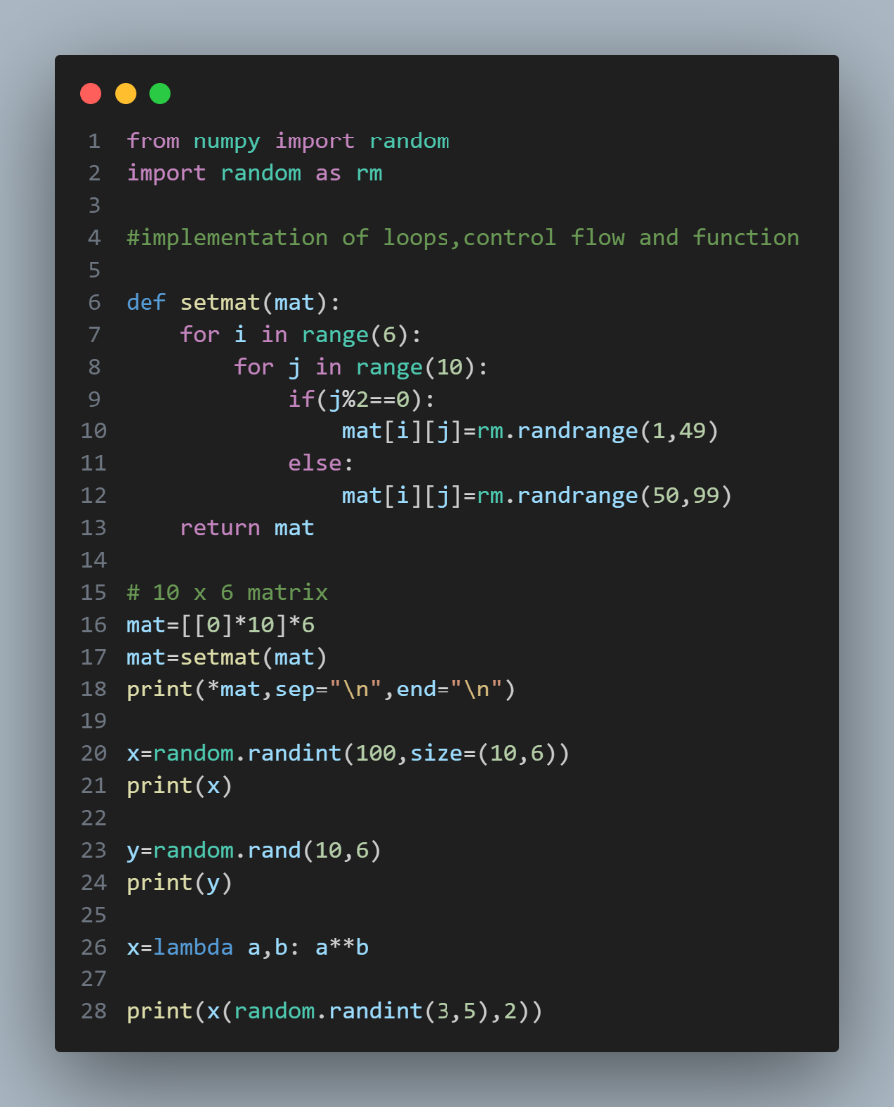**IMPLEMENTATION OF OPERATORS, CONTROL FLOW, FUNCTION, LAMBDA, RANDOM PACKAGE (RANDINT, RANDRANGE, CHOICES)**

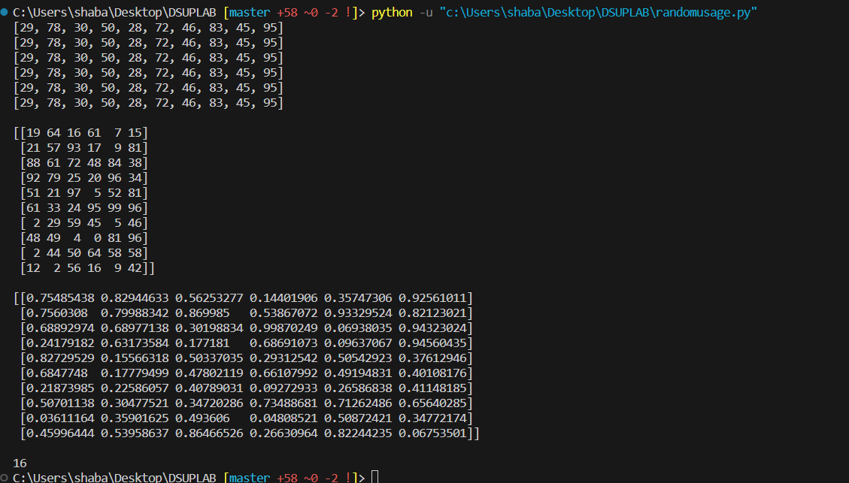

**IMPLEMENTATION OF MEAN MEDIAN MODE STANDARD DEVIATION**

